GOTO CPANEL > <https://13.235.153.213:2083>, <https://13.235.153.213:2087/>

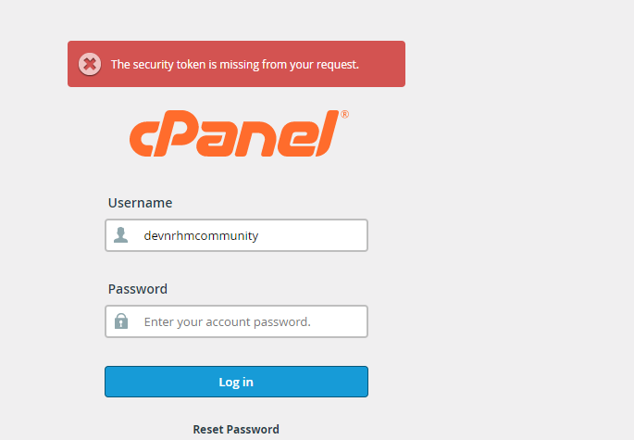

Username and password

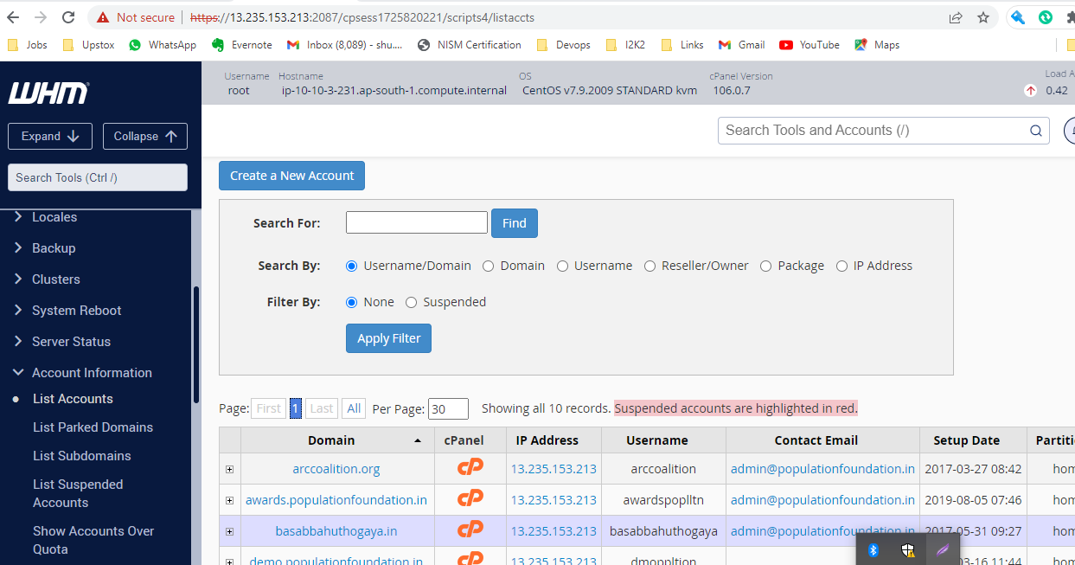

 click on cp

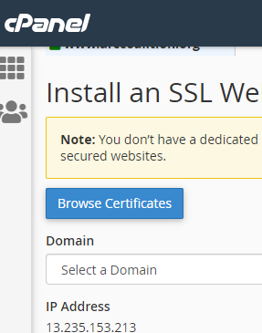

Select domain

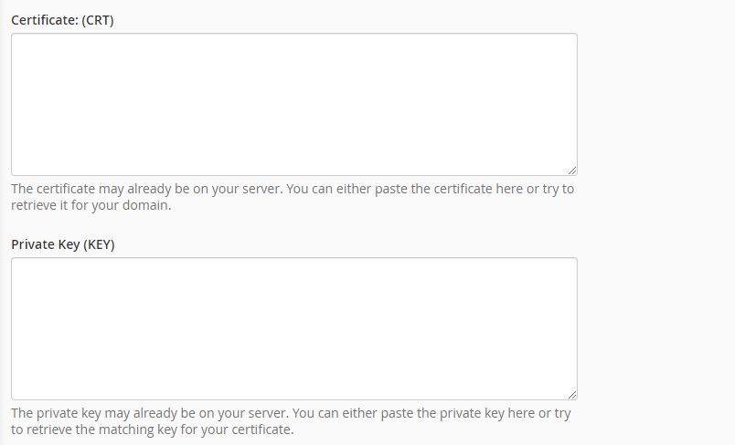

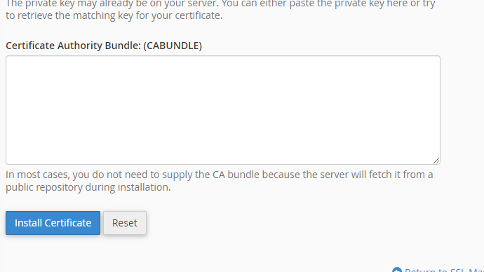

Certificate and Bundle file client will provide

Private key which generated at the time of generating CSR

[CSR Generator | Generate a Certificate Signing Request in seconds!](https://csrgenerator.com/)

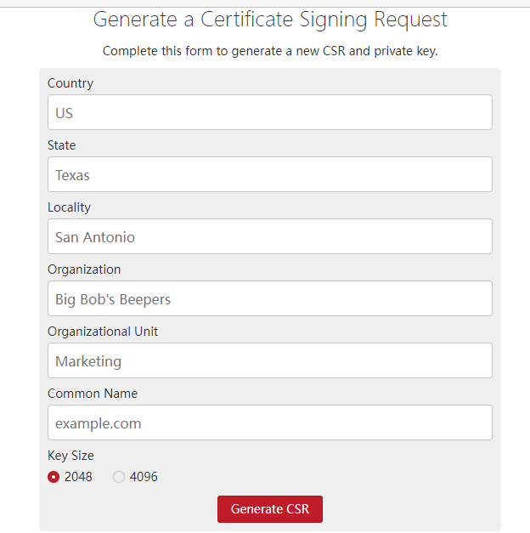

GENEARTE CSR FROM this site for every domain after that install SSL.